#### B=m **Height of a BST**

* + between O(log n) and O(n). O(log n) is what we want!
  + The height depends on the insert order:
    - ex: 1 3 2 4 5 7 6

Slow: _find takes O(n)

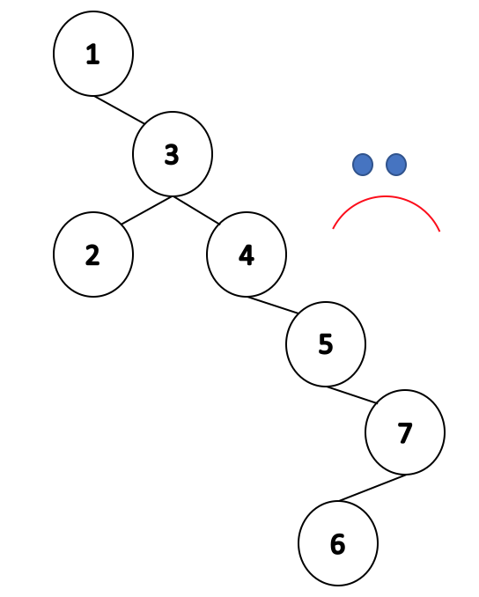

* + - ex: 4 2 3 6 7 1 5

Fast: _find takes O(log n)

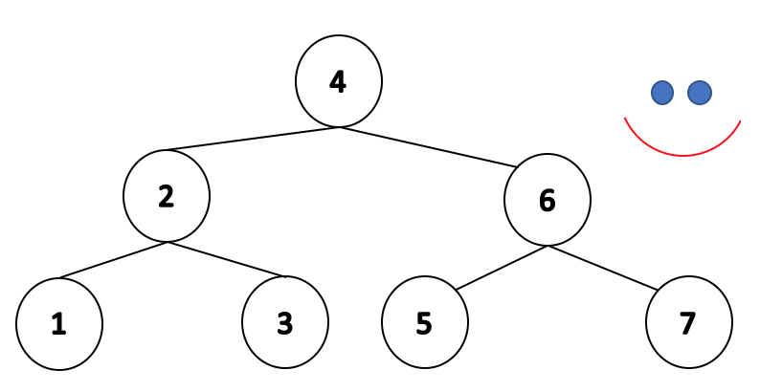

* + There are **n!** orders to input **n** elements
  + What is the average height among all trees with different input order?
    - **h** is about **log n**
    - Intuition:
      * Exactly two input order yields the worst case: linked-list-like trees

1 2 3 4 5 6 7 and 7 6 5 4 3 2 1

* + - * If 4 is the root, the tree is relatively balanced. There are 6! input orders that yield 4 as the root.
      * Therefore, averagely the tree should be relatively balanced.
  + **BUT**, when the data is ordered (which is usually good), we get our worst case!

|  |  |  |  |  |
| --- | --- | --- | --- | --- |
| **Operation** | **BST**  **Average case** | **BST**  **Worst case** | **Sorted Array** | **Sorted List** |
| **find** | O(lg n) | O(h) <= O(n) | O(lg n)  with binary search | O(n)  no binary search |
| **insert** | O(lg n) | O(h) <= O(n) | O(n)  find data with O(lg n), move the data O(n) | O(n)  find data with O(n) |
| **delete** | O(lg n) | O(h) <= O(n) | O(n) | O(n) |
| **traverse** | O(n) | O(n) | O(n) | O(n) |

* + BST out-performs array/linked-list, but the worst cases are worrying (especially with sorted data);
    - We need to make sure that we never have the worst case on BST!

#### **Height-Balanced Tree**

* + We want mountains over sticks

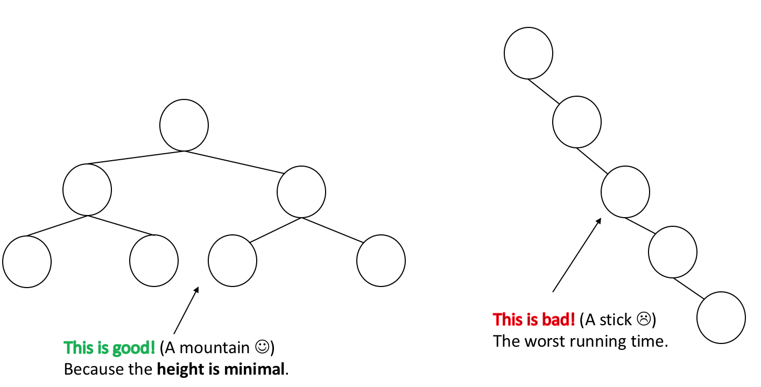

* + Balance Factor: b = height(TR) - height(TL)
    - Left heavy trees: balance factor negative
    - Right heavy trees: balance factor positive

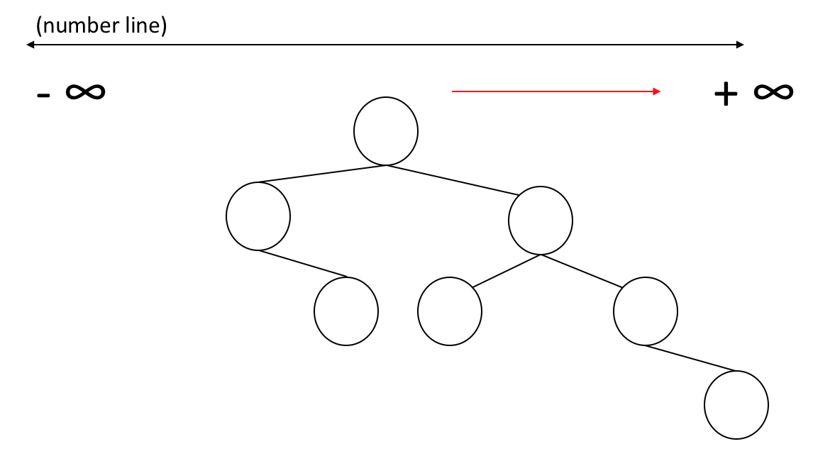

* + A tree is height balanced if **|b| <= 1**
  + Balance is determined locally

b(95) = 0 → no children; b(89) = 1; b(84) = 2 - 1 = 1; b(40) = 0; b(51) = 3 - 1 = 2; b(38) = 4 - 2 = 2

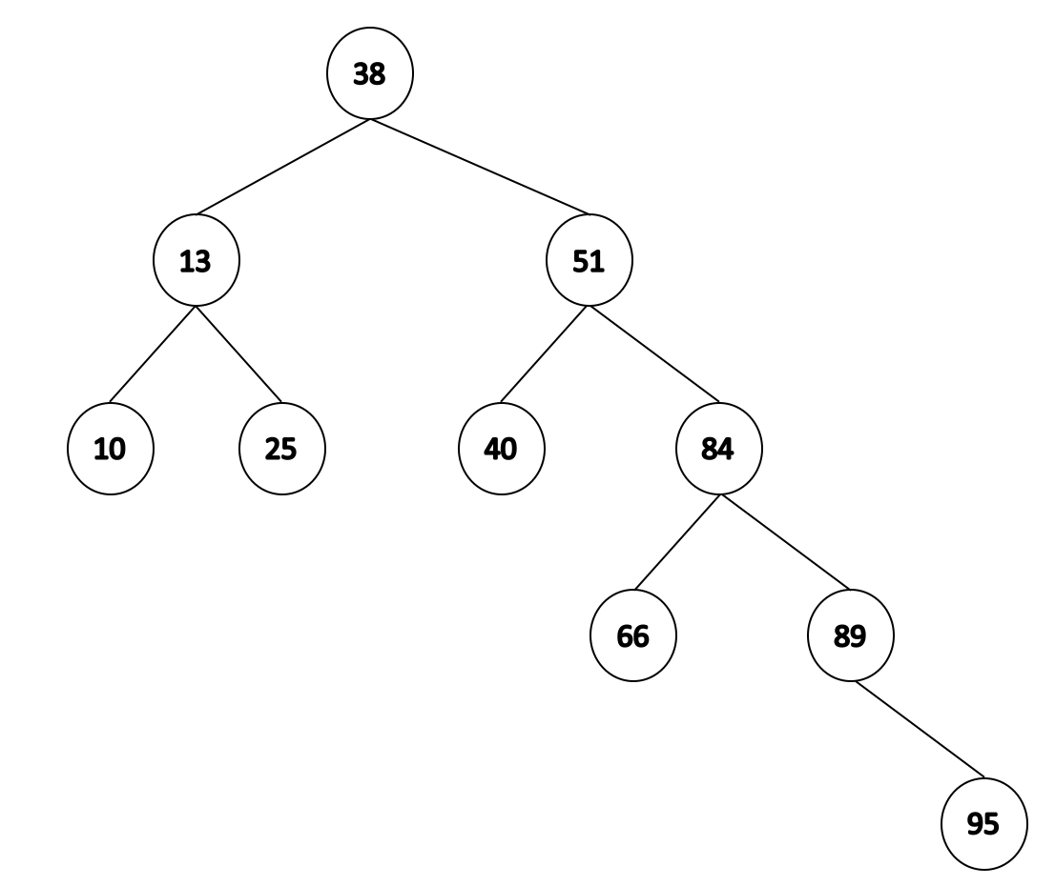

* + **The lowest point of imbalance** is the node 51. It is the deepest node in the tree that is out of balance. The tree starting at 51 looks like a stick.
    - We want to turn sticks into mountains → break into half and join (almost like folding) while preserving the BST structure.

#### **BST rotation**

* + A method to solve the imbalance:

1. Must maintain BST properties
2. Must be locally performable in O(1) time
3. Find the imbalance and the stick; 2. Break and fold the stick

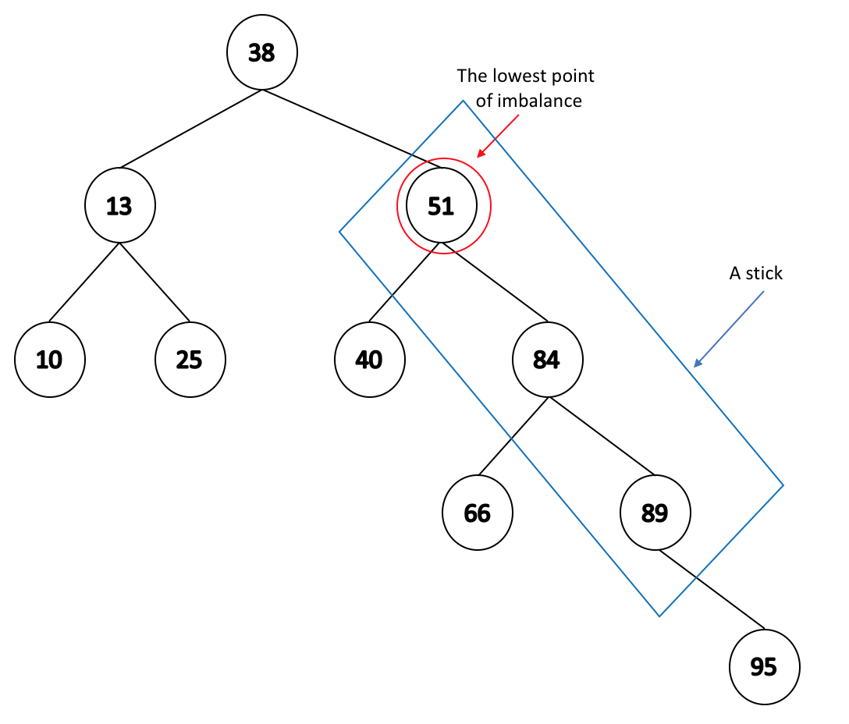 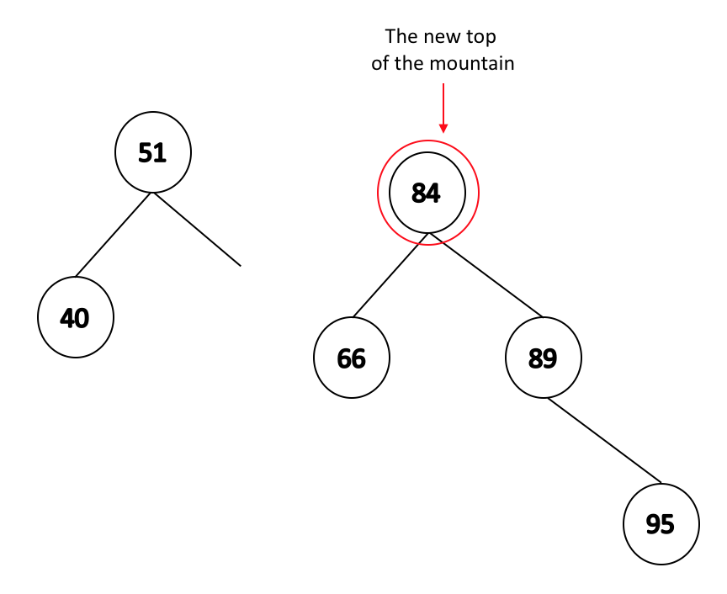

3. Move the lost element (66) 4. Create the mountain

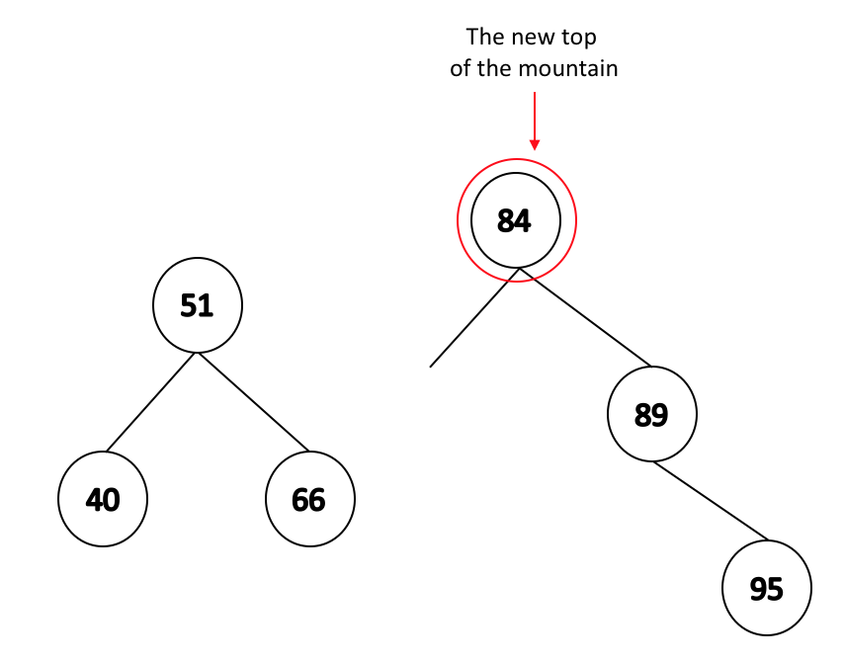 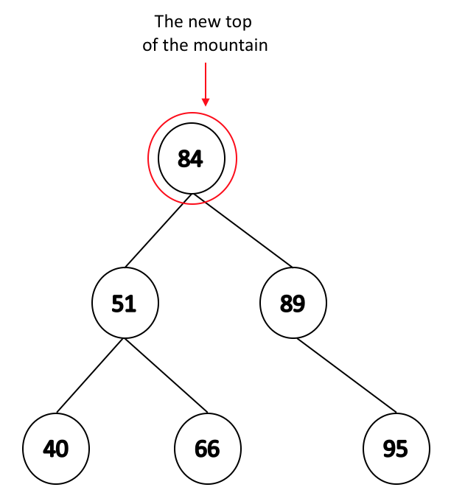

* + A picture comparing the tree before the rotation and after the rotation

